CS 499 Module One Assignment Template

Complete this template by replacing the bracketed text with the relevant information.

- Self-Introduction: Address all of the following questions to introduce yourself.

  - How long have you been in the Computer Science program?

I have been enrolled in SNHU’s computer science program for about 3 years but was enrolled in my community college, Saint Cloud Tech and Community College for 2 semesters before taking a break in 2021.

  - What have you learned while in the program? List three of the most important concepts or skills you have learned.

I have learned quite a lot while in the program. The three most important concepts and skills I have learned are best practices for developing secure code, how important user interfaces are, and how to be self-disciplined in getting work completed in a timely fashion.

  - Discuss the specific skills you aim to demonstrate through your enhancements to reach each of the course outcomes.

The specific skills I aim to demonstrate through my enhancements are my understanding of standard software and engineering principles, knowledge of algorithms and data structures, and my ability to connect software to databases.

  - How do the specific skills you will demonstrate align with your career plans related to your degree?

These skills that I will demonstrate will align with my career plans related to my degree, since I hope to be employed as a software engineer when I graduate. These skills are what a potential employer will be looking for, so having a clear example of my experience will help them decide on me as a candidate.

  - How does this contribute to the specialization you are targeting for your career?
This contributes to the specialization I am targeting for my career as it will show my skills in full-stack development to prospective clients.

- ePortfolio Set Up:

  - Submit a screen capture of your ePortfolio GitHub Pages home page that clearly shows your URL.
    - You already have a repository in GitHub where you uploaded projects in previous courses. Your ePortfolio will reside in GitHub but can link to work at other sites, such as Bitbucket.

  - Use the GitHub Pages link in the Resource section for directions on:
    - How to create your GitHub website and publish code to GitHub Pages
    - Issues, such as adding links to other sites

  - Paste a screenshot of your GitHub Pages home page with your URL clearly showing in the space below.

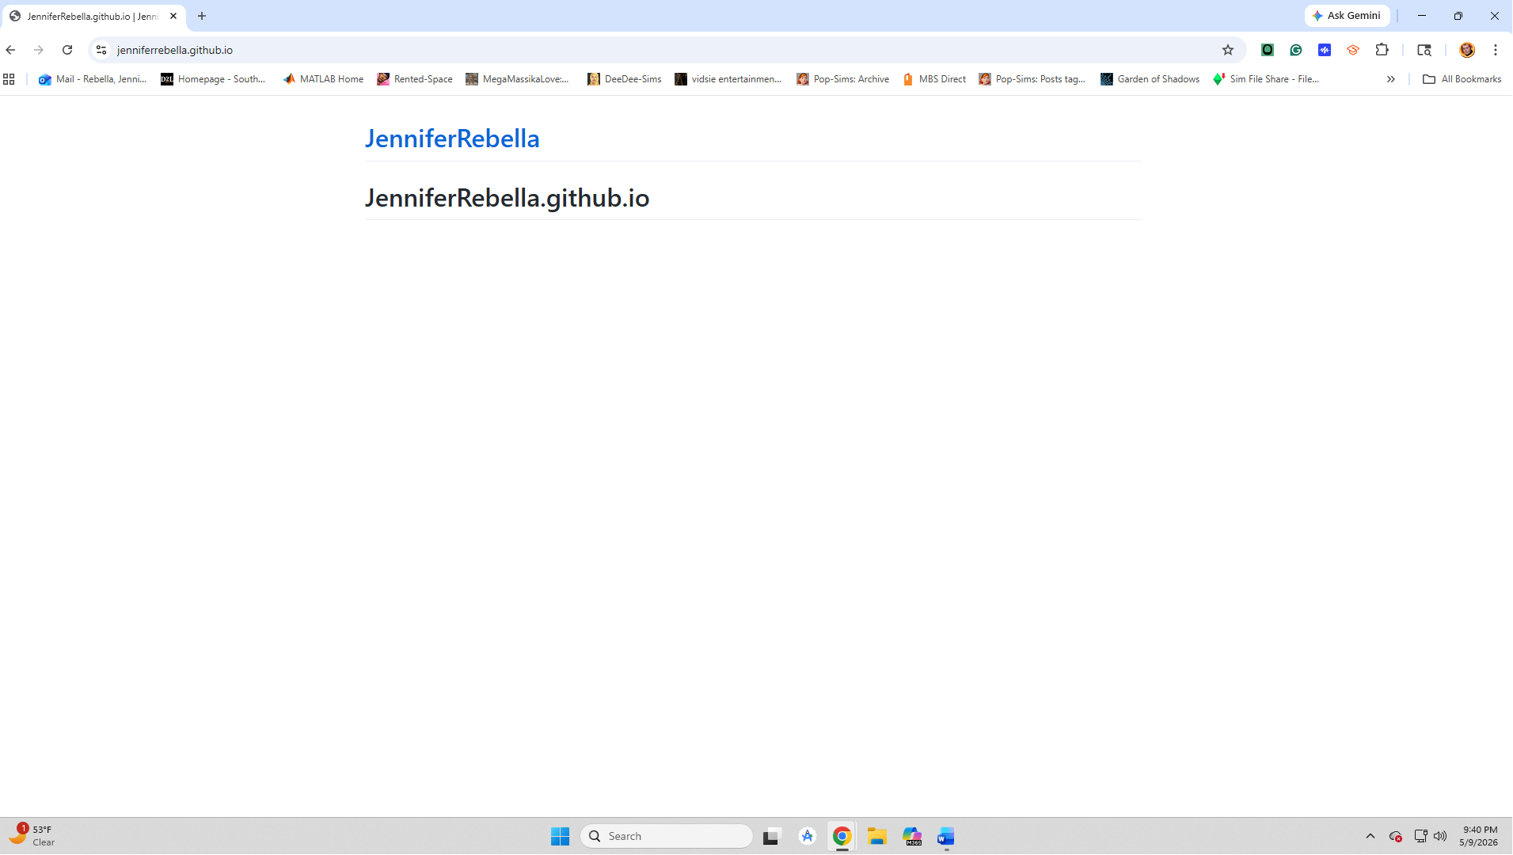
- Enhancement Plan:

  - Category One: Software Engineering and Design
    - Select an artifact that is aligned with the software engineering and design category and explain its origin. Submit a file containing the code for the artifact you choose with your enhancement plan.

The artifact that aligns with the software engineering and design category is my CS-360 Project 3. I will be turning the Android version of the store inventory application into a full-stack Apple iOS version with an extra database for another location of the store as well as adding a search engine to find items in either location.

Note: Your artifact may be work from the following courses:

- IT 145: Foundation in Application Development
- CS 250: Software Development Lifecycle
- CS 260: Data Structures and Algorithms
- IT 315: Object Oriented Analysis and Design
- CS 320: Software Testing, Automation, and Quality Assurance
- CS 330: Computational Graphics and Visualization
- CS 340: Advanced Programming Concepts
- CS 350: Emerging Systems Architectures and Technologies
- CS 360: Mobile Architecture and Programming
- IT 365: Operating Environments
- IT 380: Cybersecurity and Information Assurance
- CS 405: Secure Coding
- CS 410: Reverse Software engineering
- IT 340: Network and Telecommunication Management
- IT 380: Cybersecurity and Information Assurance

    - Describe a practical, well-illustrated plan for enhancement in alignment with the category, including a pseudocode or flowchart that illustrates the planned enhancement.

The enhancement I’m planning to make to this artifact is to make a full-stack Apple IOS version of the inventory tracker app, which is currently coded just for the Android operating system. To complete this task, I will look up the best practices for Apple’s IOS and what the requirements are to be able to release on their app store, as well as converting them to Swift.
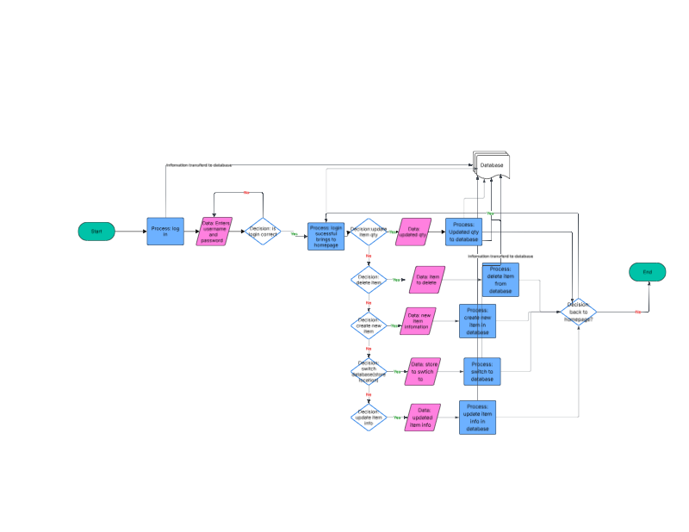
For this category of enhancement, consider improving a piece of software, transferring a project into a different language, reverse engineering a piece of software for a different operating system, or expanding a project’s complexity. These are just recommendations. Consider being creative and proposing an alternative enhancement to your instructor.

Think about what additions to include to complete the enhancement criteria in this category. Since one example option is to port to a new language, that is the kind of scale that is expected. This does not mean you need to port to a new language but instead have an equivalent scale of enhancement. Underlying expectations of any enhancement include fixing errors, debugging, and cleaning up comments, but these are not enhancements themselves.

    - Explain how the planned enhancement will demonstrate specific skills and align with course outcomes.

      - Identify and describe the specific skills you will demonstrate that align with the course outcome.

The specific skills that will be demonstrated from this enhancement are my skill in creating programs for multiple operating systems, that I can create full-stack applications with best practices in mind, I am able to build secure applications, and that I can design within the limitations of the systems in use, and proficiency in Swift.

      - Select one or more of the course outcomes below that your enhancement will align with.

The course outcomes that align with my enhancements are:
- Demonstrate an ability to use well-founded and innovative techniques, skills, and tools in computing practices for the purpose of implementing computer solutions that deliver value and accomplish industry-specific goals.

Course Outcomes:

- Employ strategies for building collaborative environments that enable diverse audiences to support organizational decision-making in the field of computer science.
- Design, develop, and deliver professional-quality oral, written, and visual communications that are coherent, technically sound, and appropriately adapted to specific audiences and contexts.
- Design and evaluate computing solutions that solve a given problem using algorithmic principles and computer science practices and standards appropriate to its solution while managing the trade-offs involved in design choices.
- Demonstrate an ability to use well-founded and innovative techniques, skills, and tools in computing practices for the purpose of implementing computer solutions that deliver value and accomplish industry-specific goals.
- Develop a security mindset that anticipates adversarial exploits in software architecture and designs to expose potential vulnerabilities, mitigate design flaws, and ensure privacy and enhanced security of data and resources.

  - Category Two: Algorithms and Data Structures

- Select an artifact that is aligned with the algorithms and data structures category and explain its origin. Submit a file containing the code for the artifact you choose with your enhancement plan. You may choose work from the courses listed under Category One.
The artifact that aligns with the software engineering and design category is my CS-360 Project 3. I will be turning the Android version of the store inventory application into a full-stack Apple iOS version with an extra database for another location of the store, as well as adding a search engine to find items in either location.
- Describe a practical, well-illustrated plan for enhancement in alignment with the category, including a pseudocode or flowchart that illustrates the planned enhancement.
The enhancements I plan to make to this inventory app, so it is in alignment with algorithms and data structures, are to improve the efficiency of the application as well as add a search engine for the user to find items with ease.

For this category of enhancement, consider improving the efficiency of a project or expanding the complexity of the use of data structures and algorithms for your artifact. These are just recommendations. Consider being creative and proposing an alternative enhancement to your instructor. Note: You only need to choose one type of enhancement per category.

Think about what additions to include to complete the enhancement criteria in this category. Since one example option is to port to a new language, that is the kind of scale that is expected. Perhaps you might increase the efficiency and time complexity of an algorithm in an application and detail the logic of the increased time complexity. Remember, you do not need to port to a new language but instead have an equivalent scale of enhancement. Underlying expectations of any enhancement include fixing errors, debugging, and cleaning up comments, but these are not enhancements themselves.

- Explain how the planned enhancement will demonstrate specific skills and align with course outcomes.

  - Identify and describe the specific skills you will demonstrate to align with the course outcome.

The specific skills that I will be demonstrating are my understanding of the basics of algorithms and data structures, as well as my understanding of how to optimize applications and add new functionality to existing programs.

  - Select one or more of the course outcomes listed under Category One that your enhancement will align with.

- Design and evaluate computing solutions that solve a given problem using algorithmic principles and computer science practices and standards appropriate to its solution, while managing the trade-offs involved in design choices.
- Develop a security mindset that anticipates adversarial exploits in software architecture and designs to expose potential vulnerabilities, mitigate design flaws, and ensure privacy and enhanced security of data and resources.

  - Category Three: Databases

    - Select an artifact that is aligned with the databases category and explain its origin. Submit a file containing the code for the artifact you choose with your enhancement plan. You may choose work from the courses listed under Category One.

The artifact that aligns with the software engineering and design category is my CS-360 Project 3. I will be turning the Android version of the store inventory application into a full-stack Apple iOS version with an extra database for another location of the store, as well as adding a search engine to find items in either location.

    - Describe a practical, well-illustrated plan for enhancement in alignment with the category, including a pseudocode or flowchart that illustrates the planned enhancement.

The enhancements I plan to make to this inventory app, so it is in alignment with databases, are to improve the existing database so it functions well with the new Swift Apple iOS version of the application, as well as adding a new MongoDB interface with HTML/JavaScript for the additional storefront.

For this category of enhancement, consider adding more advanced concepts of MySQL, incorporating data mining, creating a MongoDB interface with HTML/JavaScript, or building a full stack with a different programming language for your artifact. These are just recommendations; consider being creative and proposing an alternative enhancement to your instructor. Note: You only need to choose one type of enhancement per category.

Think about what additions to include to complete the enhancement criteria in this category. Since one example option is to port to a new language, that is the kind of scale that is expected. Perhaps you might increase the efficiency and time complexity of an algorithm in an application and detail the logic of the increased time complexity. Remember, you do not need to port to a new language but instead have an equivalent scale of enhancement. Underlying expectations of any enhancement include fixing errors, debugging, and cleaning up comments, but these are not enhancements themselves.
    - Explain how the planned enhancement will demonstrate specific skills and align with course outcomes.

      - Identify and describe the specific skills you will demonstrate that align with the course outcome.

The specific skills that I will demonstrate are my competence in MongoDB and my ability to work with databases as a whole.

      - Select one or more of the course outcomes listed under Category One that your enhancement will align with.

- Develop a security mindset that anticipates adversarial exploits in software architecture and designs to expose potential vulnerabilities, mitigate design flaws, and ensure privacy and enhanced security of data and resources

- ePortfolio Overall Skill Set

  - Accurately describe the skill set to be illustrated by the ePortfolio overall.
    - Skills and outcomes planned to be illustrated in the code review
The specific skills that I will demonstrate are the ability to construct applications in many languages like Swift, C++, and Python, as well as my understanding of full-stack applications, and my skills in database. It will also be a show of my skills in constructing secure code that follows security and industry best practices, so that my code is easily understood by other professionals in this field.

- Design and evaluate computing solutions that solve a given problem using algorithmic principles and computer science practices and standards appropriate to its solution while managing the trade-offs involved in design choices.
- Demonstrate an ability to use well-founded and innovative techniques, skills, and tools in computing practices for the purpose of implementing computer solutions that deliver value and accomplish industry-specific goals.
- Develop a security mindset that anticipates adversarial exploits in software architecture and designs to expose potential vulnerabilities, mitigate design flaws, and ensure privacy and enhanced security of data and resources.

    - Skills and outcomes planned to be illustrated in the narratives
The specific skills that I will demonstrate are my ability to construct a narrative for a project and that I am able to pitch ideas in a concise and clean order. This will show that I am proficient in my understanding of the applications I am creating.

- Design, develop, and deliver professional-quality oral, written, and visual communications that are coherent, technically sound, and appropriately adapted to specific audiences and contexts.
- Employ strategies for building collaborative environments that enable diverse audiences to support organizational decision-making in the field of computer science.

    - Skills and outcomes planned to be illustrated in the professional self-assessment
The specific skills that I will demonstrate are my ability to construct an objective analysis of my skills and how I would be an asset to whatever team I am a part of in the professional environment. I will be able to show how I am able to put my skills together to provide an accurate description of my work. This will help illustrate my worth in communicating with clients and other professionals that I am working with.

- Employ strategies for building collaborative environments that enable diverse audiences to support organizational decision-making in the field of computer science.
- Design, develop, and deliver professional-quality oral, written, and visual communications that are coherent, technically sound, and appropriately adapted to specific audiences and contexts.

